A Memorandum

**To:** Nuri Emanetoglu, Associate Professor / Andrew Sheaff, Lecturer

**From:** Ryan Dufour, Undergraduate (CE) RD / Phillip Robb Undergraduate (EE) PR

**Date:** September 18, 2018

**Subject:** Part Order 1 Justification

The schematic below was created using Eagle by Autodesk. A frequency sweep was conducted to meet the specifications as far as gain is concerned. Using the TLV6004 IC OP AMP, this was achieved using a two stage filter, which produced a gain of approximately 25 dB with frequencies greater than 1 kHz being attenuated by at least 20 dB. The quad core package was chosen because if we needed a larger drop in gain, more stages could be cascaded in order to meet specifications. In addition, the op amps would be similar to each other as they are made on the same wafer. The TLV6004 op amp IC is also rail to rail input and output, allowing for the signal from the microphone to pass through. Gain bandwidth is a negligible factor as the guitar tuner will only be dealing with frequencies between 60 Hz and 440 Hz. The 1 MHz bandwidth is acceptable for this application. The simulations worked appropriately so further testing of this component is required. There is a possibility of needing a BJT input stage if noise becomes an issue, but testing of the part is first required. In addition, the voltage reference circuit to set the DC offset of the signal is yet to be determined. The Digilent Analog Discovery 2 will be used to set this voltage for this phase of the design. Future considerations include using a Zener diode as a shunt, or a dedicated reference voltage IC package to set this voltage.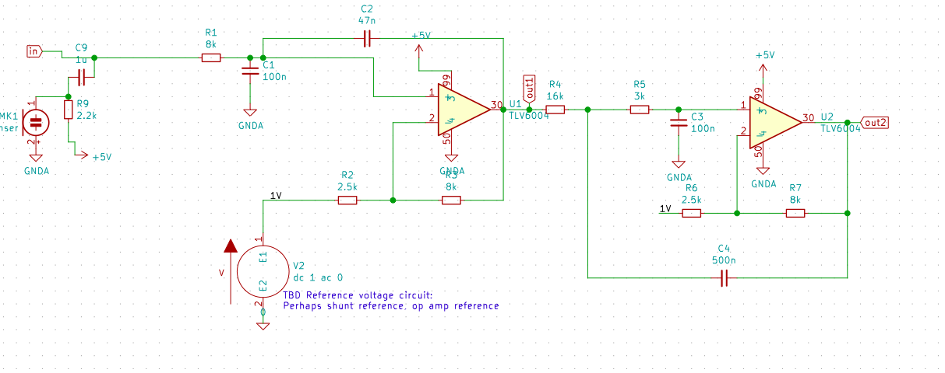

The gain can be seen in the plot below over a frequency range greater than 1 kHz. The red line shows the gain in dB vs frequency, while the blue line indicates the phase in degrees vs frequency. The simulations were performed using NGSpice.

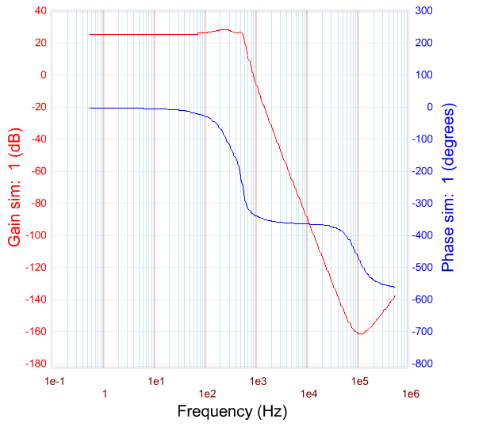

A buck converter is needed to reduce the voltage supplied by the battery to the appropriate 5V needed for the TLV6004 IC OP AMP. The reasoning is that it is the best choice to choose an IC buck converter in order to obtain a better signal than if analog parts are used. This specific IC buck converter was chosen using certain specifications. First, the maximum output ripple is seen in the data sheet in Figure 26. It shows an approximate voltage ripple of 5mV peak to peak. This is well within specifications. Next, the output current will be in the range of 500mA, and the efficiency at this amperage is at 85% which is acceptable, since the tuner will not be running at all times. The quiescent current is another consideration. At a 9V voltage input, the quiescent current is approximately 700 uA. This is fairly high, but as the device has an off switch, and the amount of time the tuner will be used, power consumption is not a primary concern. Lastly, the input voltage could be anywhere from 6V to 12V depending on the future choices of battery. We are assuming for the time being, a 9V power source or battery will be used for this guitar tuner, as it is a fairly common power source for most guitar electronics. The IC buck converter will reduce the voltage down to the 5V needed for the two stage operational amplifier active filter. The Schottky diode is used conduct the inductor current when the MOSFET stage of converter is off. The Schottky increases the efficiency of the converter because it features a low forward voltage which helps deliver power with minimal losses to the load. The diode was chosen such to feature 3A current tolerance, which is 1A higher than the maximum current deliverable by the buck-converter. The inductor was chosen to have a resonant frequency (20 MHz) greater than the switching frequency of the buck converter (700kHz). In addition the maximum current rating (2.7A) was selected to be greater than the maximum current deliverable by the Buck Converter (2A).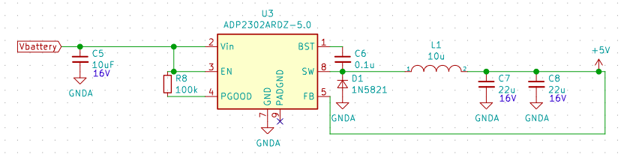

The choice of capacitors for the order are 22 uF ceramic capacitors. Since they are ceramic that have a low ESR, their contribution to output ripple is small.

The breakout boards are required because of the need for testing components on a prototype board before PCB design. The justification is the need to test all IC components because currently, the team would be unable to test the surface mount components. Each breakout board selected corresponds to the appropriate integrated circuits, for optimal fitting.

More condenser microphones are needed in case the current one fails. The microphone is the part required to induce an electrical signal in the circuit that is to be analyzed. It is also a passive device that has two pins, an output and reference so interfacing with a breadboard prototype will be feasible. The operating range of the microphone is 20Hz to 20kHz, which is wide enough to capture the signals of interest for this project. In addition, the microphone features a sensitivity of -44dB ±2dB where 0dB is 1V/1Pa, this is enough to recreate the acoustic signal as an electrical signal.

The resistors, due to the prototype nature of this stage, are subject to change, as result the resistors available in the Parts Cabinet of the ECE department will be used to facilitate this stage of the design. The filter stage is a higher order filter, therefore as the design progresses low tolerance resistors (1%) will be used after values are determined.